# Logitech G502 Review

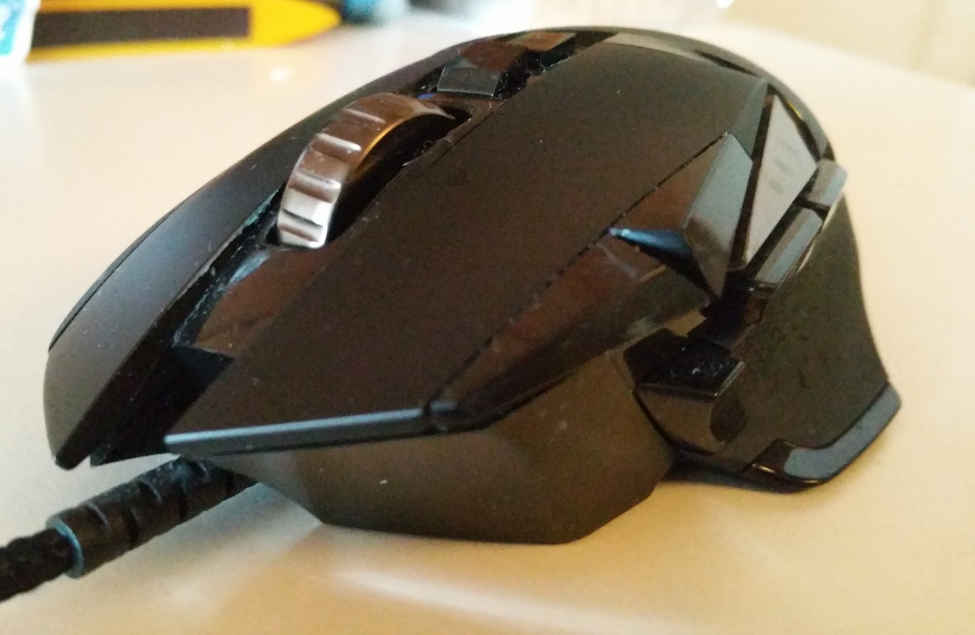Logitech has been known for making top of the line gaming mice for years now. So how does the G502 hold up to this high standard? What functionalities and product quality can you expect to get from a $60 mouse? This and much more will be covered in this review of the Logitech G502.

## Features

Logitech G502 is a common name for the Logitech G502 Proteus core and the Logitech G502 Proteus Spectrum, where the only difference is that the Spectrum features custom RGB lighting and is considered the upgraded version of the Core. Otherwise the 2 mice are identical.  
The G502 sports 11 programmable and completely customizable buttons, whereas 3 of these are your standard mouse buttons (mouse click left, mouse click right, and mouse wheel click) and the 8 others are customs buttons which you can customize to your liking.   
The mouse has a high accuracy optical sensor and allows DPI values ranging from 200 to 12000.  
One of the most beloved features about the G502 is the adjustable weight. The bottom panel of the mouse is attached with magnets, allowing easy removal without randomly falling off during use. Underneath you will find a huge field where you can place 6 included weights which allows you to customize the weight and balance of the mouse to your liking.   
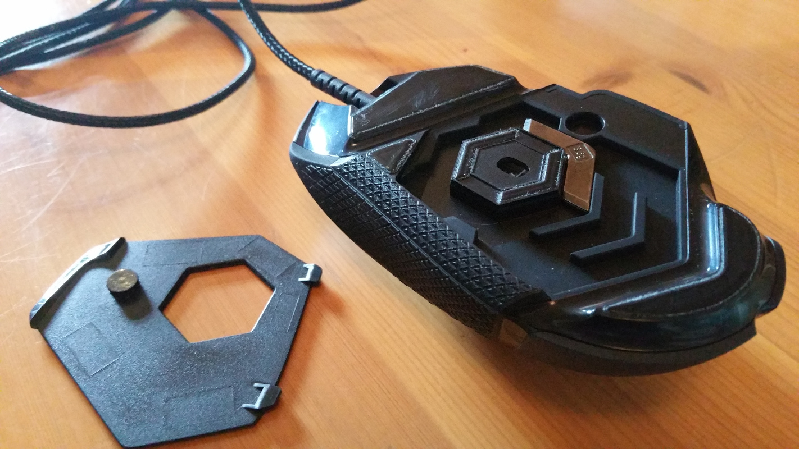The G502 Proteus Spectrum features custom RGB lighting on the “G” logo on the mouse and allows for a grand total of 16,8 million different colour combinations to choose from.   
All software configurations can be saved onto the 3 on-board mouse profiles for easy switching between different button and lighting setup. The on-board profiles even support button macros.

## Ergonomics

The G502 feels good in the palm of the hand and all the buttons are reachable without any special effort. The rubberized sides of the mouse give extra grip, as well as extra comfort for your thumb and pinkie. There is even a thumb-rest for more stability and comfort. The buttons feel high quality and provide good tactile feedback when clicked, especially the standard left and right click buttons.   
One of the biggest selling points for the G502 are the easily adjustable weights. The magnetic bottom panel allows you to change the weight distribution and overall weight of the mouse without having to use a screwdriver or any other tools to add, change or remove weight. There are hundreds of different possible combinations, so you can find which one you like. The mouse come included with a case for you to keep the additional weights that you don’t end up using, so they don’t end up missing.

## Functionality

As mentioned before, the mouse has a total of 11 buttons, that can all be customized to your liking (even the left and right click). Every button supports macro functions, so you can even make a button do powerful keyboard combinations or open a specific program.   
The mouse DPI can be changed from 200 to 12000 as well as the polling rate of the sensor can be changed. Most users will probably find themselves using between 200 and 4000 DPI as the mouse becomes really sensitive to movement above these values. Most people will opt for the 1000 or 500 options for the polling rate, as the 125 and 250 setting can make the mouse movement feel laggy and choppy.   
The G502 Proteus Spectrum which supports custom RBG lighting will allow you to change this in the Logitech Gaming Software.  
The Logitech Gaming software is required to adjust all these settings, but once the mouse has been customized you can save your settings to 3 individual profiles on the on-board memory and you will be able to use all your customized features completely independent of the Logitech Gaming Software.

## Conclusion

Logitech G502 has become one of the most popular gaming mice in recent years. With its focus on customizability and functionally for gaming its easy to understand why. The design is beautiful, its ergonomic, it sports a load of features. I believe Logitech has created the close to, if not, perfect gaming mouse.